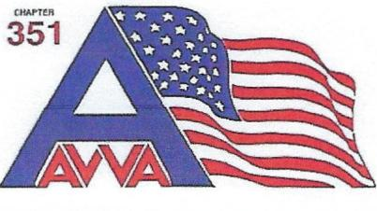

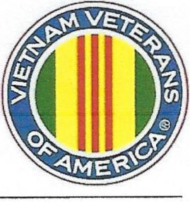
Vietnam Veterans of America
Appleton Area Chapter 351
Appleton, WI 54912-1862
vvawi351.org

VIETNAM VETERANS OF AMERICA, APPLETON AREA CHAPTER 351
RICHARD POUKEY MEMORIAL SCHOLARSHIP
ELIGIBILITY – A graduating senior attending an area high school or a child/grandchild of a Chapter 351 Vietnam Veteran member.
SUBMISSION – Write an original narrative essay based on your interview with any US military veteran of any branch of service who served on active duty anywhere in the world during the 16 year period January 1, 1959 to May 7, 1975. We hope that by opening a cross generational dialogue with a Vietnam Veteran you have an opportunity to learn history directly from a veteran who lived it and may gain a deeper understanding of their youth goals, life experiences, and value challenges.

You, the student, may be a dependent, relative, or acquaintance of your interview subject. If you are not able to connect with a qualifying veteran of your own choosing contact VVA 351, Wade Van Ryzin at 920-540-0924, prior to March 1st for the name of a member to interview. You must be a US citizen or permanent resident of the USA.
SCHOLARSHIP - The scholarship is intended to assist in alleviating some of the expenses incurred
in furthering your post-secondary education. There are four scholarships available, in the amount of $1,500.00 each. The winners will receive their check following the completion of one semester at a post-secondary facility including technical college.
APPLICATION – Please submit of the following:
Application form
Transcripts – official copy of high school grade transcripts
Proof of Service Statement by Veteran – DD214 accepted
Essay – A double-spaced, three to five page interview narrative essay, in 10 or 12 point font.
The most critical aspects of the narrative essay are what you have learned from the interview and how you express those ideas. Your entry will be scored based on originality, appearance and grammar (verbatim or basic question/answer formats will not be accepted).

All data must be postmarked by March 31st. The four successful candidates will be notified by May 1st.

All materials are to be returned to:

VVA Appleton Area Chapter 351 Scholarship Committee
Wade Van Ryzin
N3011 Steeple Drive, Appleton, WI 54913

Congratulations graduate!

Wade Van Ryzin
For further Information: ON WEB PAGE www.vvawi351.0rg
Vietnam Veterans of America Chapter 351 Scholarships

Also check for additional scholarships:
Vietnam Veterans of America State Scholarships
Vietnam Veterans of America National Scholarships

If you have questions or desire additional information, please contact Wade Van Ryzin at 920-540-0924.

